Creating Linux Machine(EC2) and Installing Webserver

1 STEP 1

Login to [AWS Console](https://signin.aws.amazon.com/signin?redirect_uri=https%3A%2F%2Fconsole.aws.amazon.com%2Fconsole%2Fhome%3Fstate%3DhashArgs%2523%26isauthcode%3Dtrue&client_id=arn%3Aaws%3Aiam%3A%3A015428540659%3Auser%2Fhomepage&forceMobileApp=0&code_challenge=DQPPPPwJLFPYXZ).

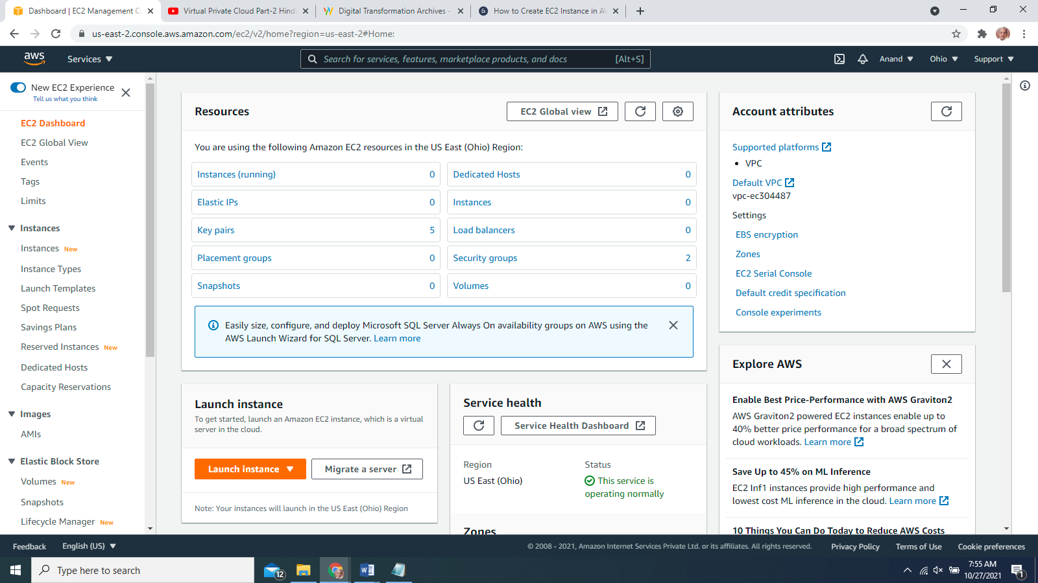

Launch Instance(Free Tier)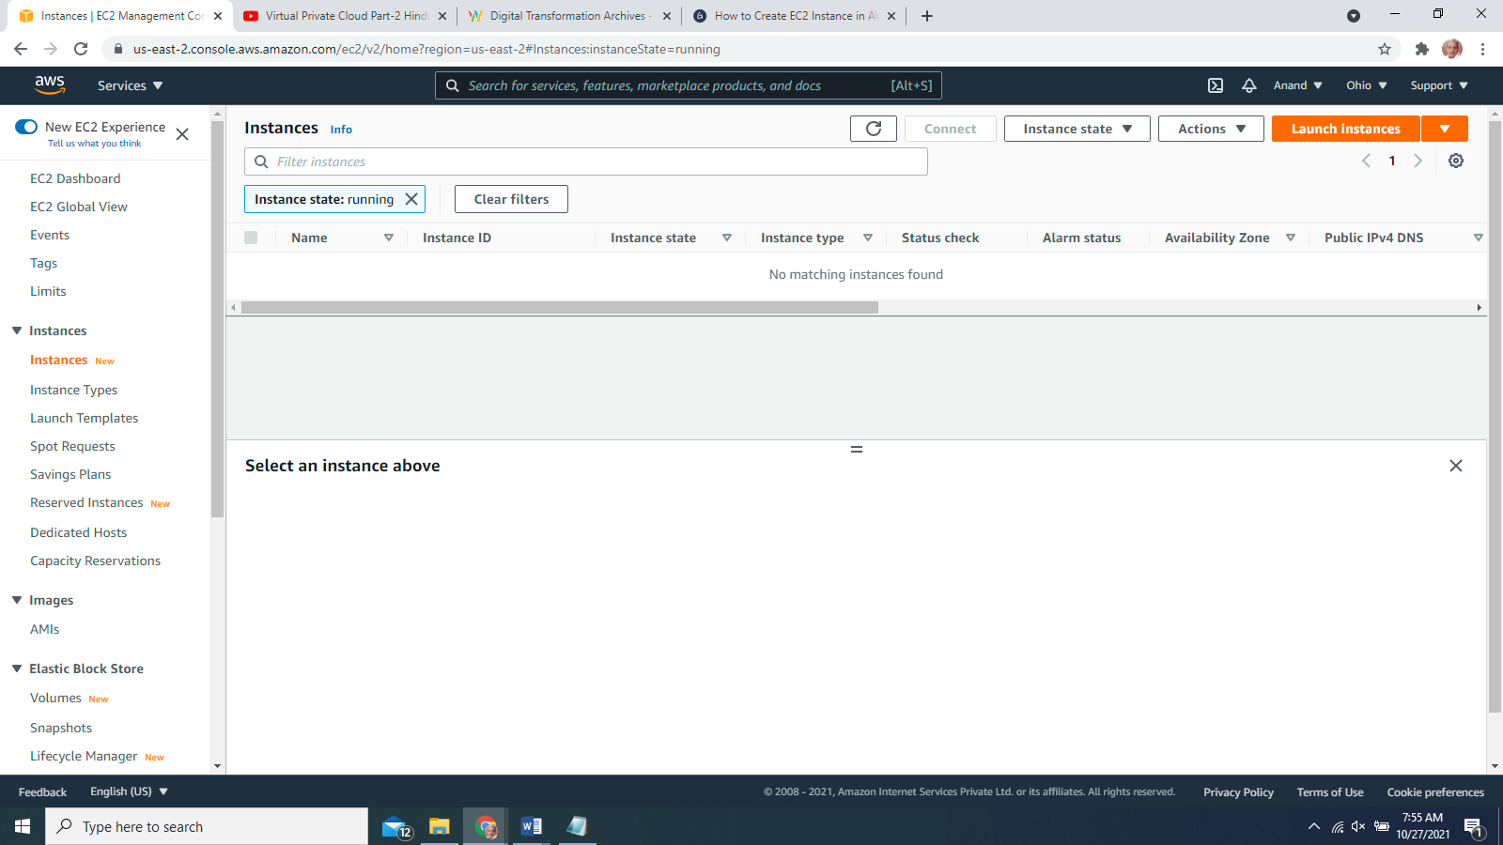

Select Amazon Linux(Free tier)

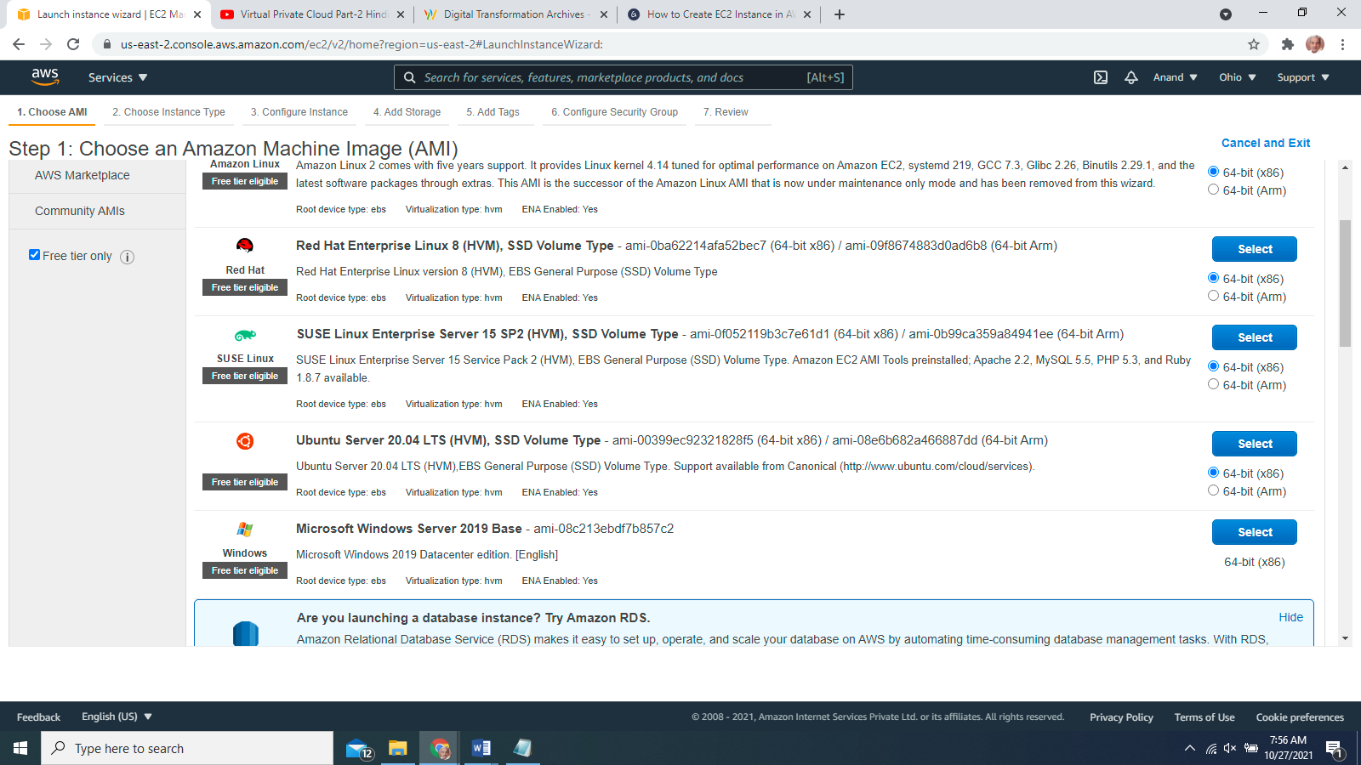

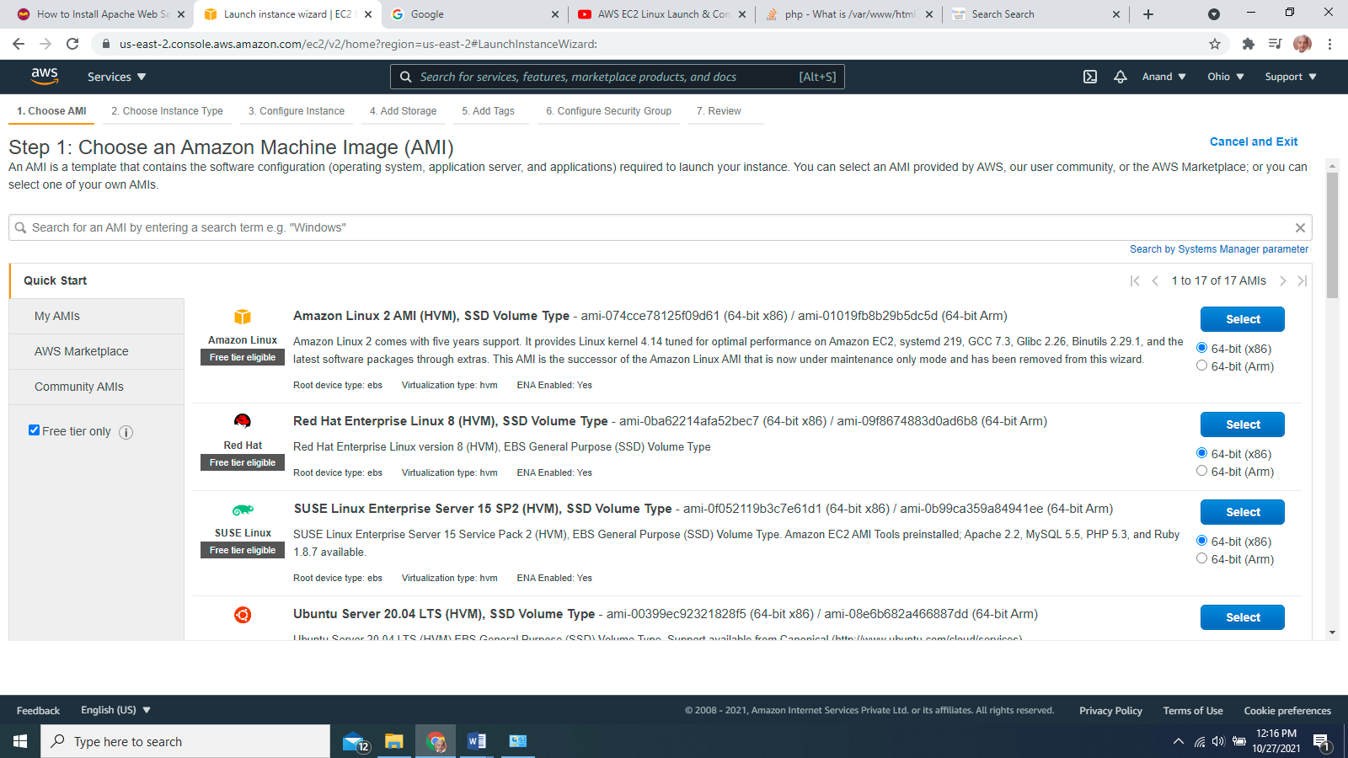

Type t2.micro

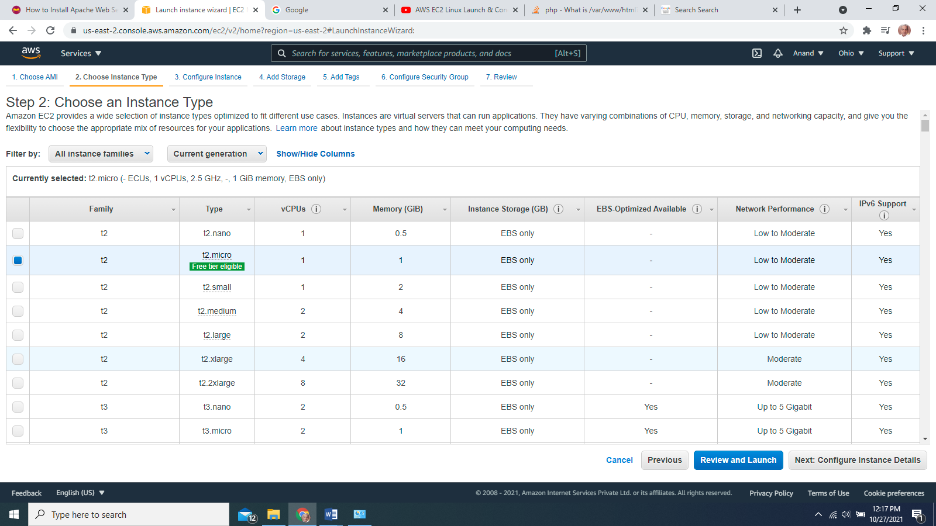

Numbe of Instanc=1

VPC Default

Subnet no pref

Auto Assign IP Enable

Storage Default

Tag Name webserver-linux

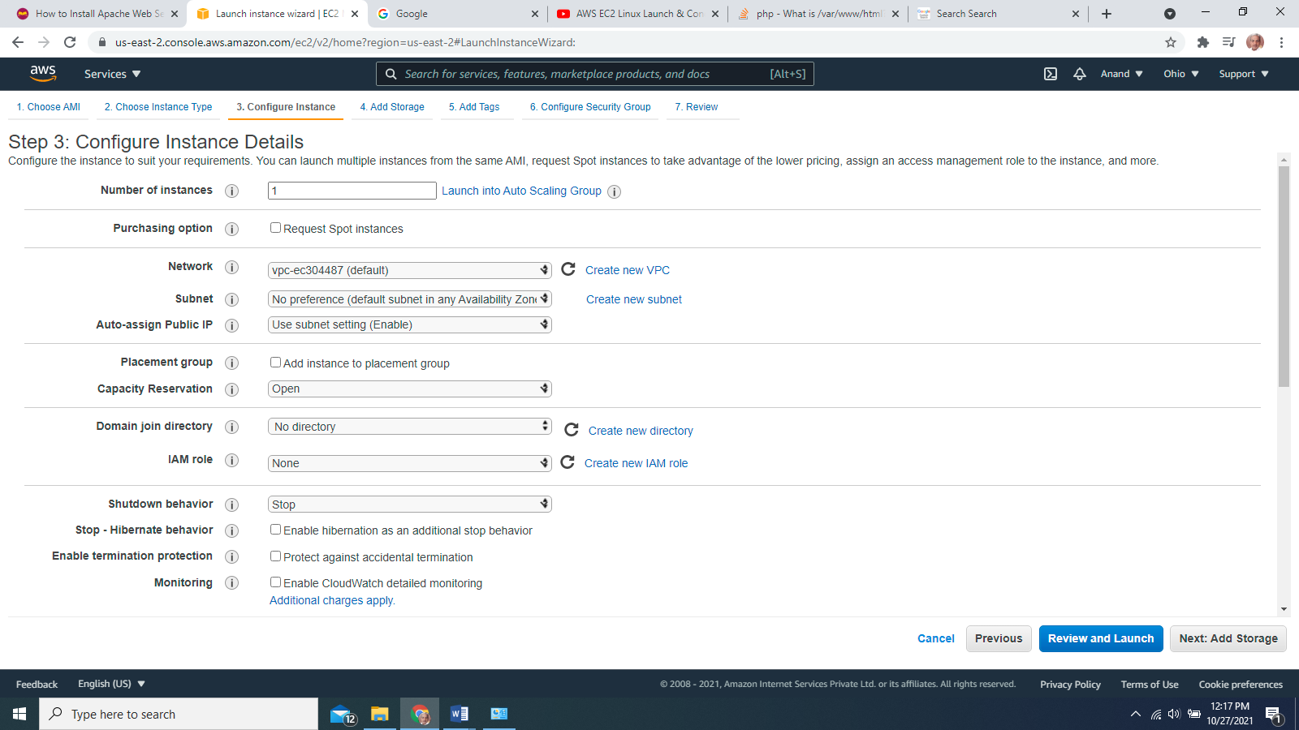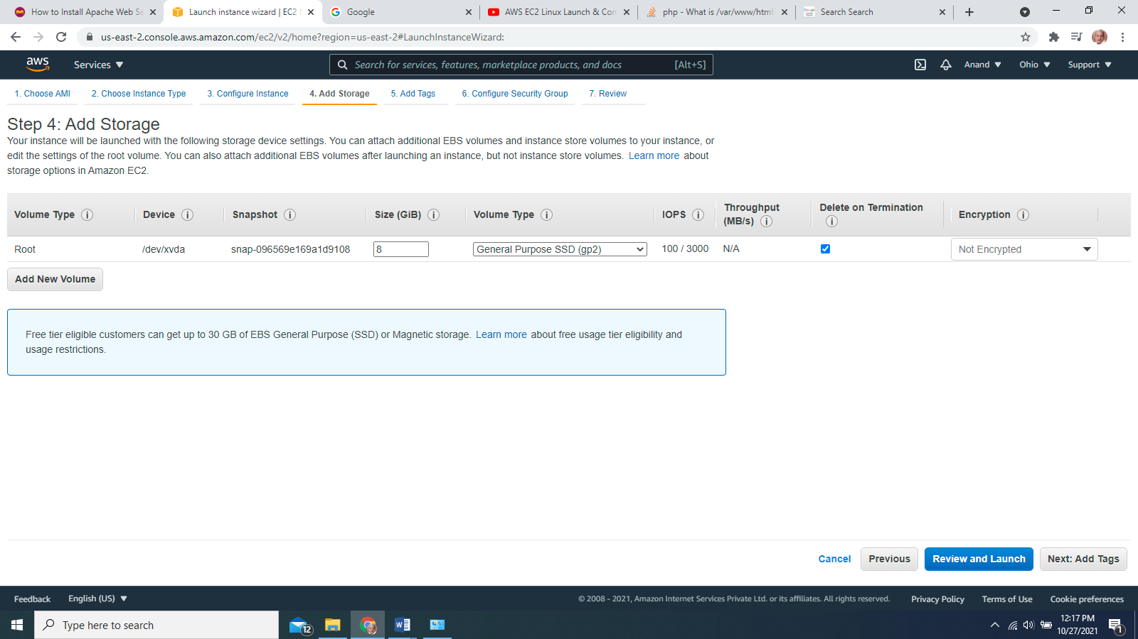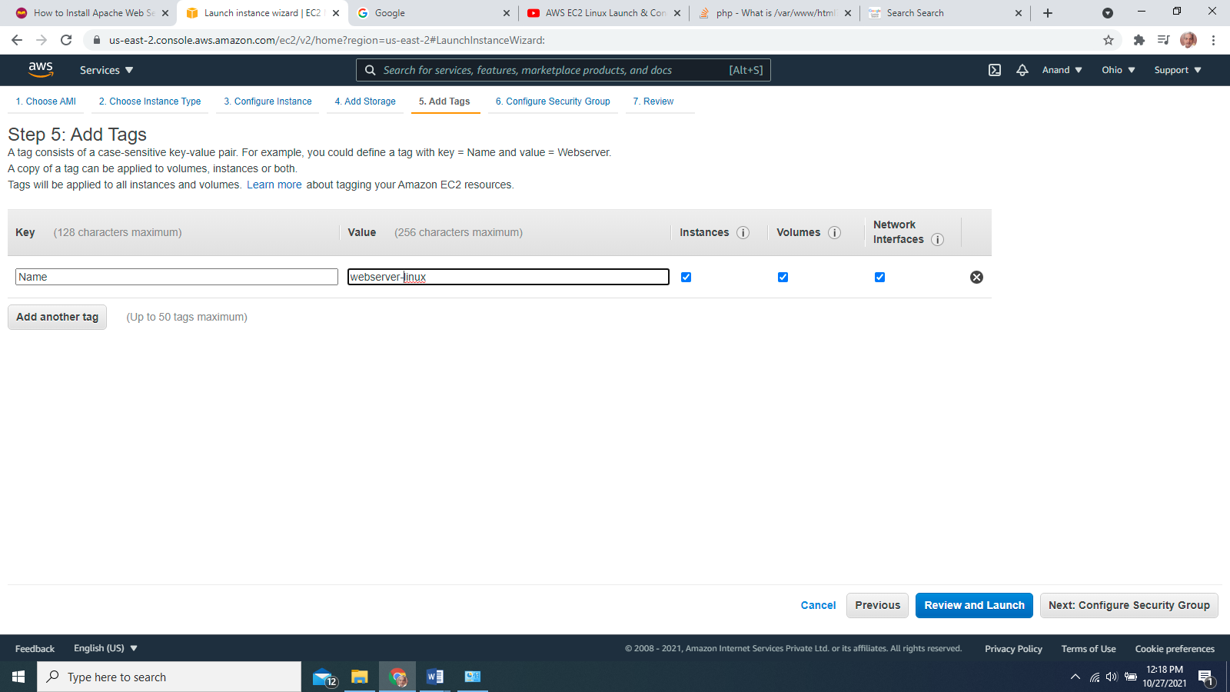

Security Group Linuxsg

Add rules

ssh tcp 22 anywhere

ssh http 80 anywhere

ssh https 455 anywhere 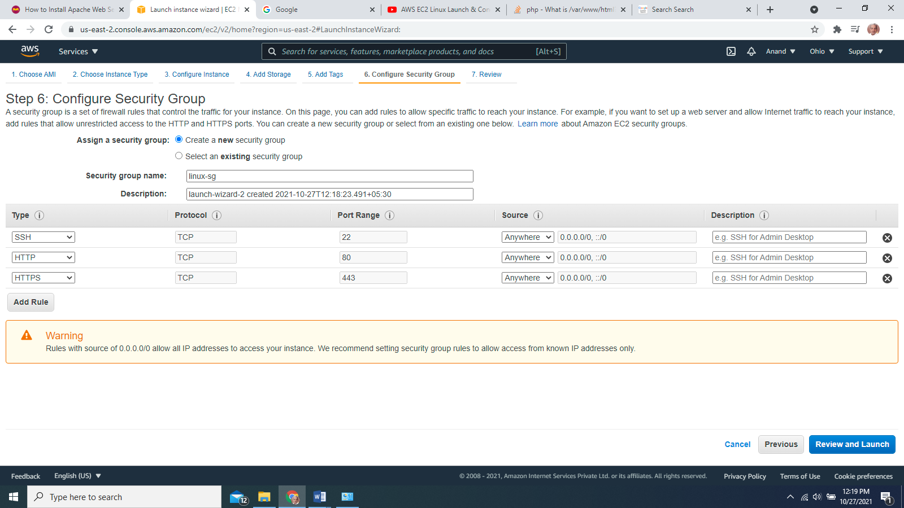

Review and launch

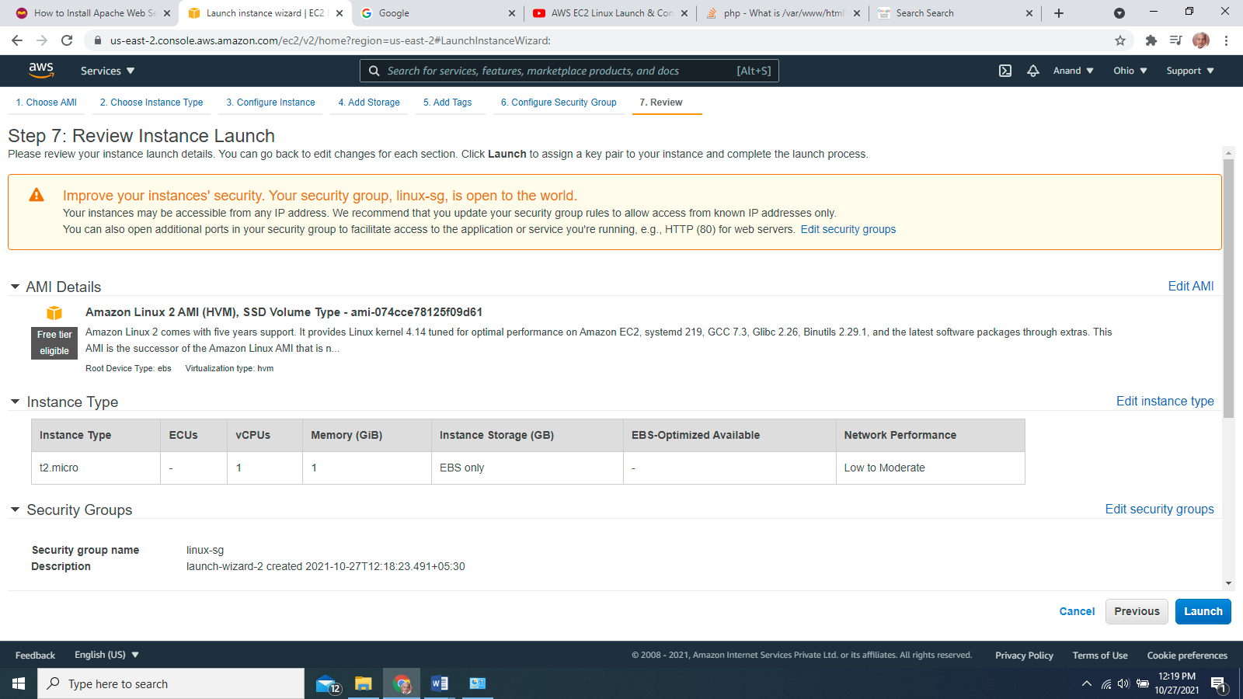

Create key Pair wenserverlinuxkp (extension will be .pem)

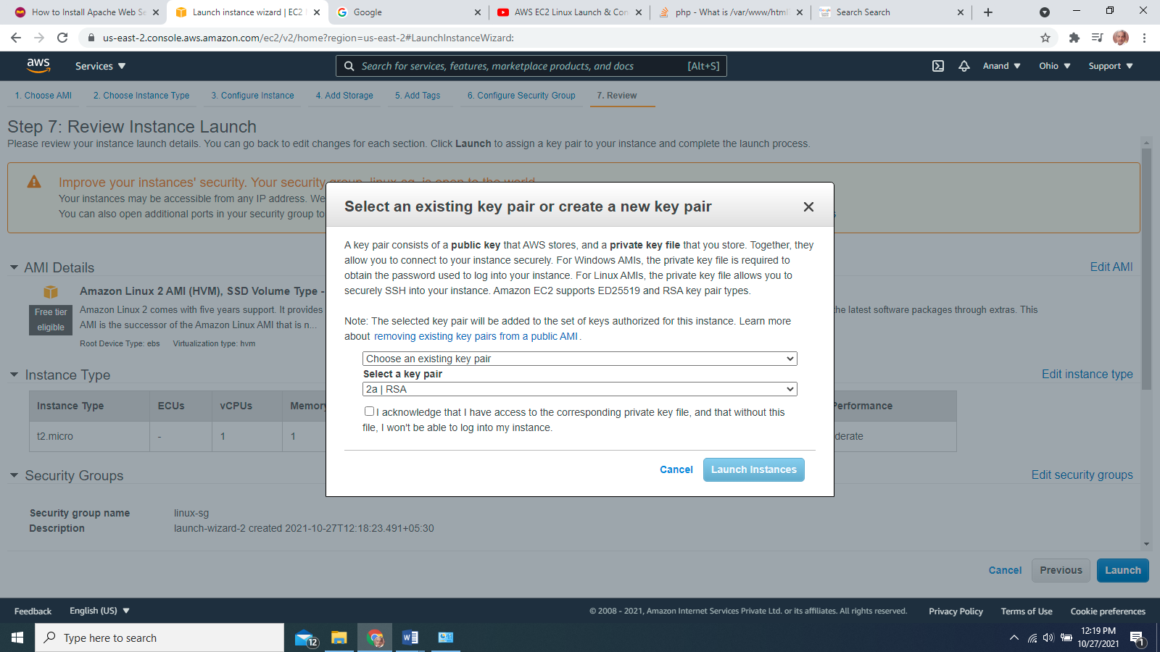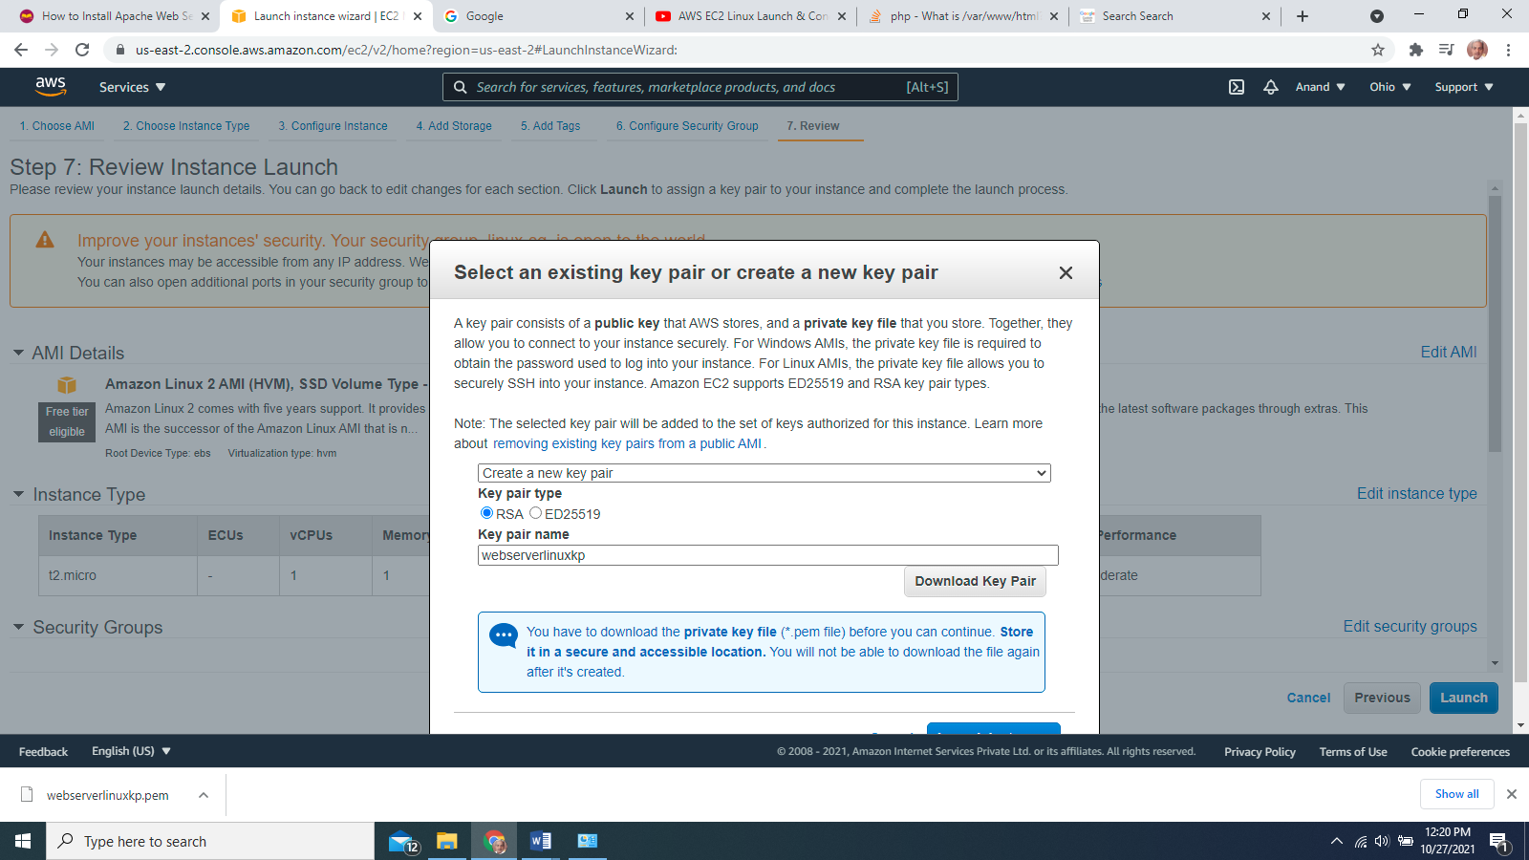

Let the instance be launched when launched copy the public ip of the instance

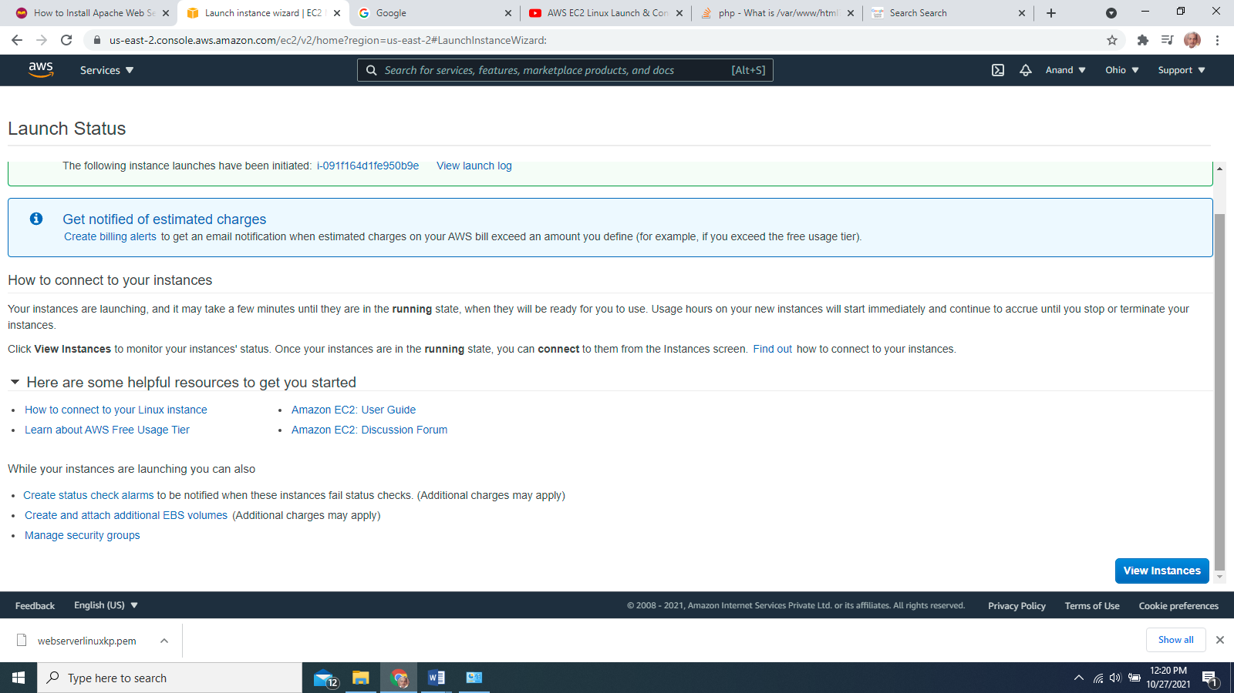

Open puttygen (to convert .pem file to .ppk)

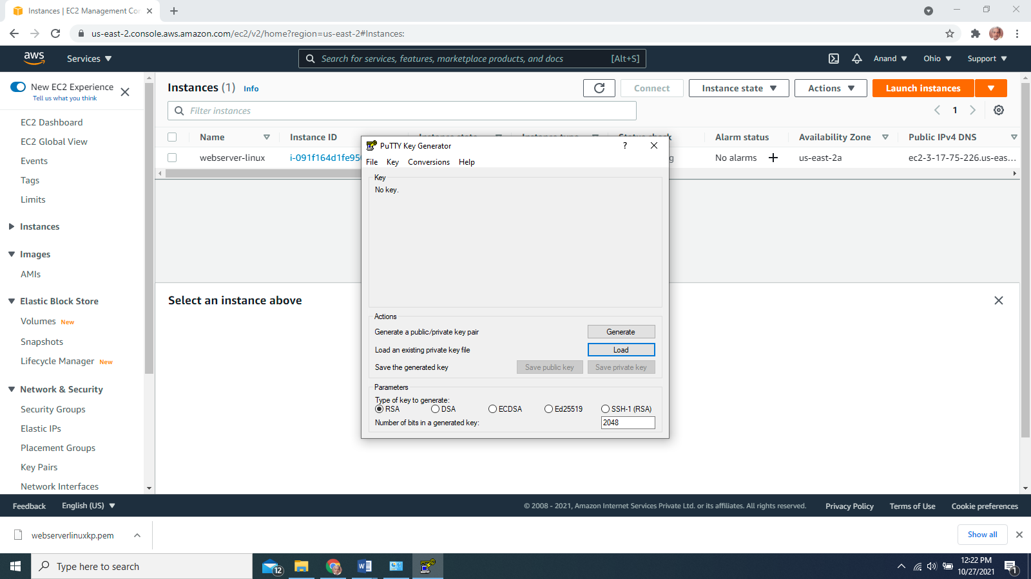

Load the downloaded wenserverlinuxkp.ppk file

Open puttygen.exe and load the weserverlinuxkp.pem private key you downloaded when you created the ec2 instance.

It looks like*“*weserverlinuxkp.pem*“*. Once you open the .pem file a pop-up window will appear, asking you to save the private key. Click ok and click the save private key button.

Save theweblinuxpvtkp.ppk file in any folder.

***Note:****Do not click generate a key or any other buttons. Just load the pem file and click the save the private key button.*

[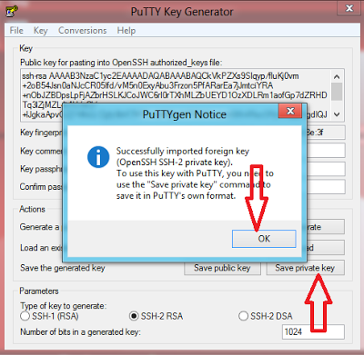](https://4.bp.blogspot.com/-7sz3EztvHbQ/UNU-DDO6kDI/AAAAAAAAAi0/lF7G0hWX1sU/s1600/1.PNG)

Then save private key as weblinuxpvtkp.ppk

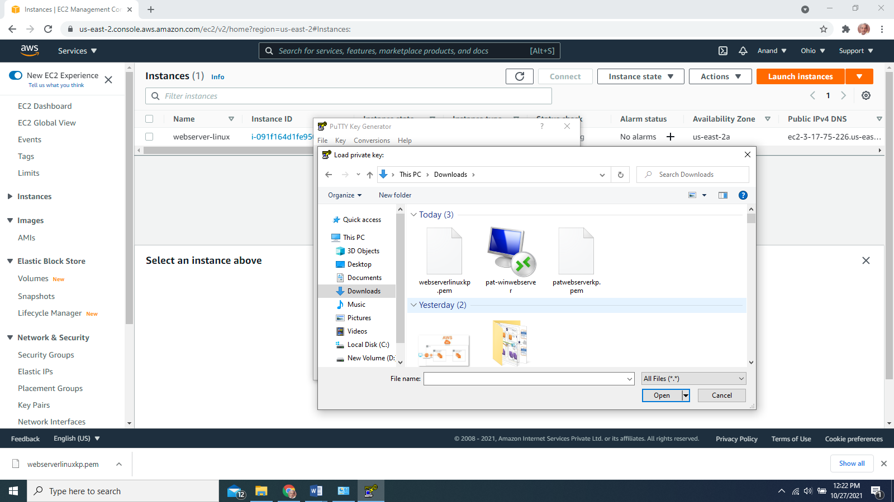

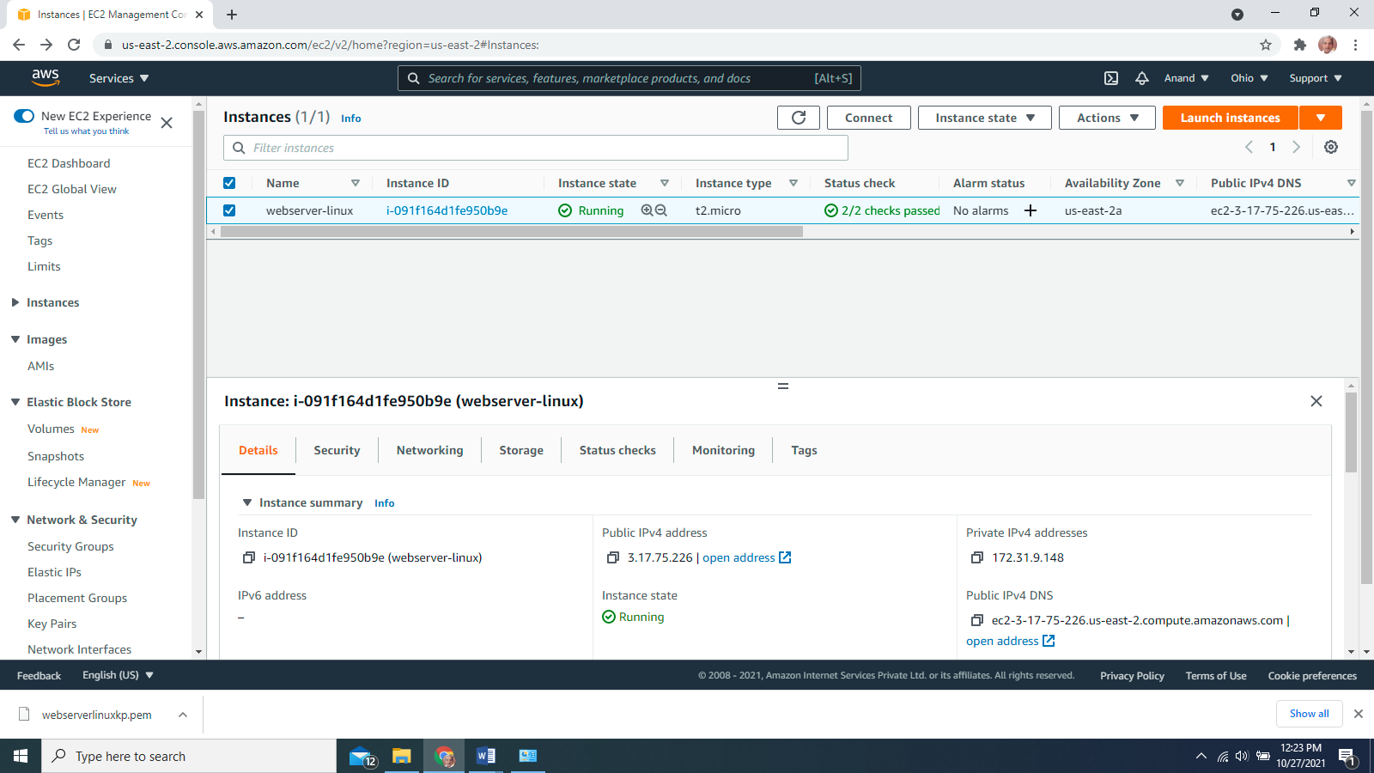

Note the details public IP address and user name

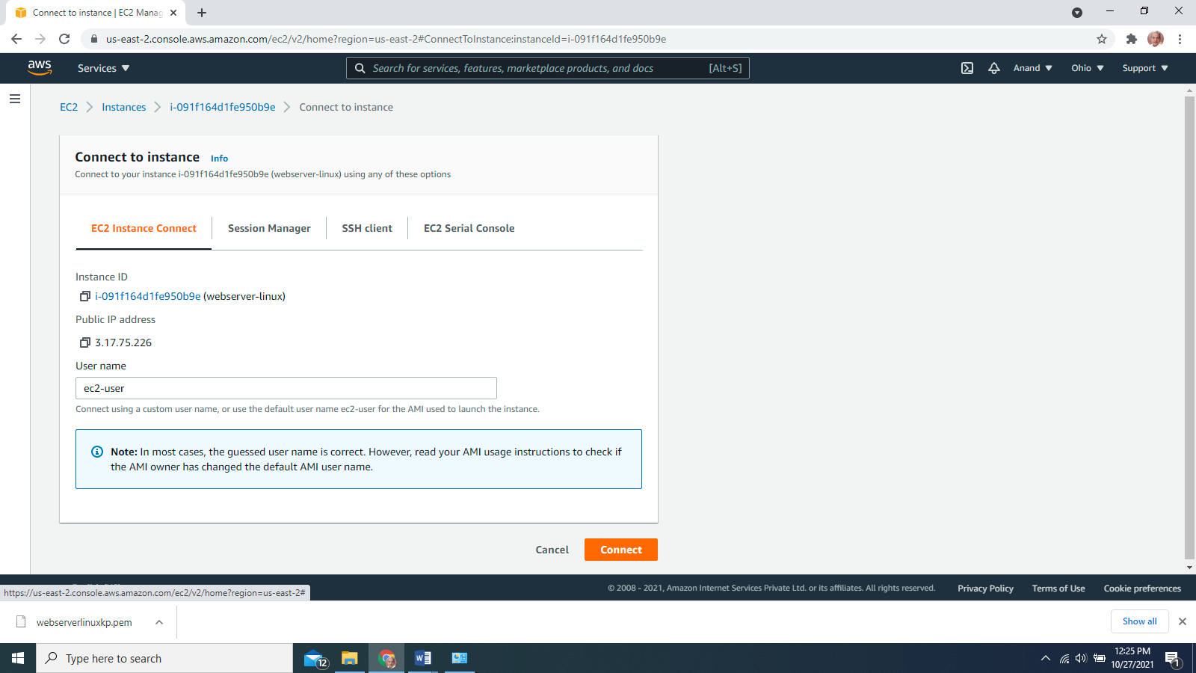

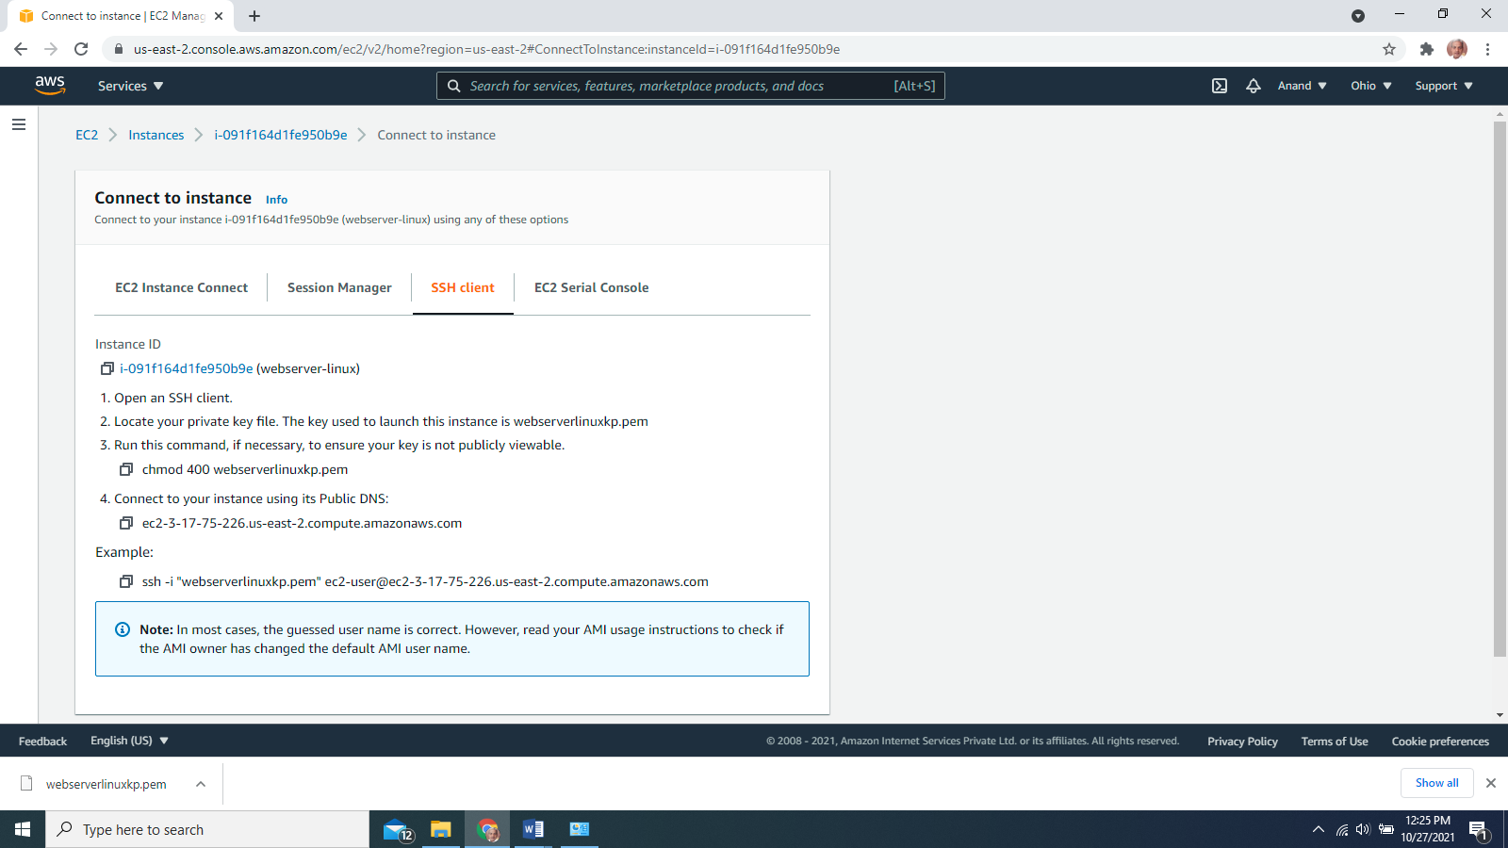

Open Putty

Paste the Public IP

ssh auth browse select weblinuxpvtkp.ppk

open

yes

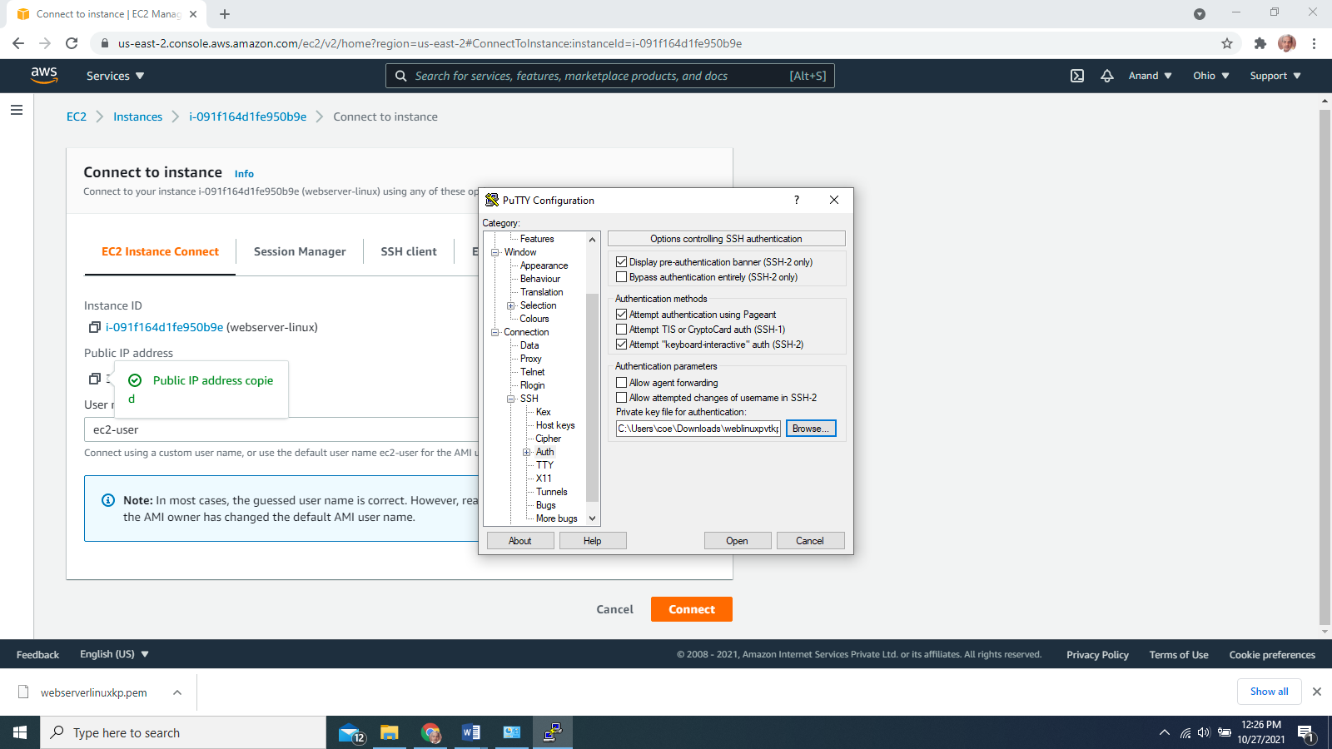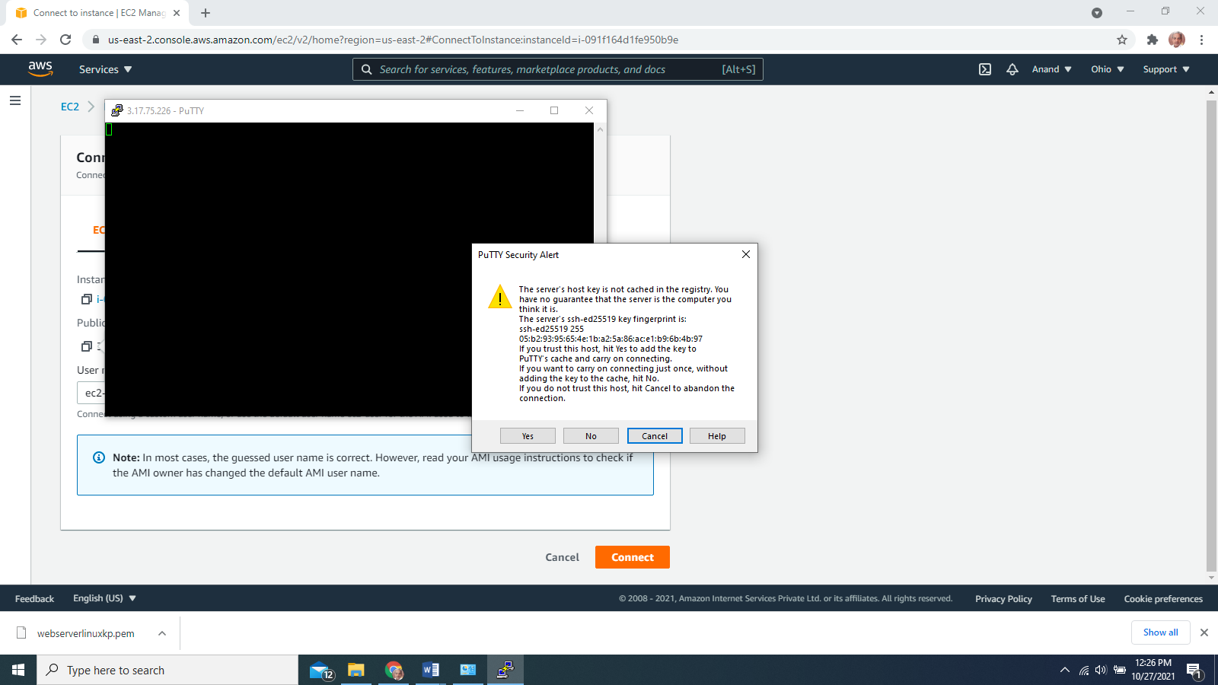

Login as ec2-user (default)

sudo su (for root access)

yum install httpd –y

service httpd status

service httpd start

service httpd status

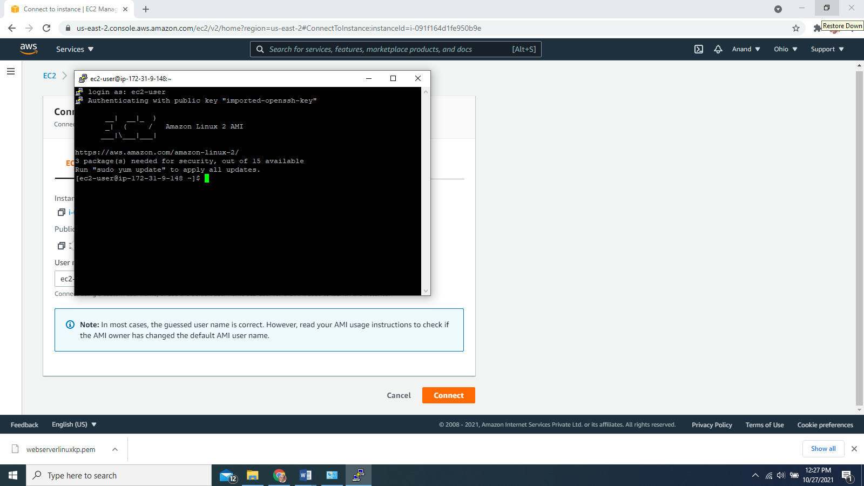

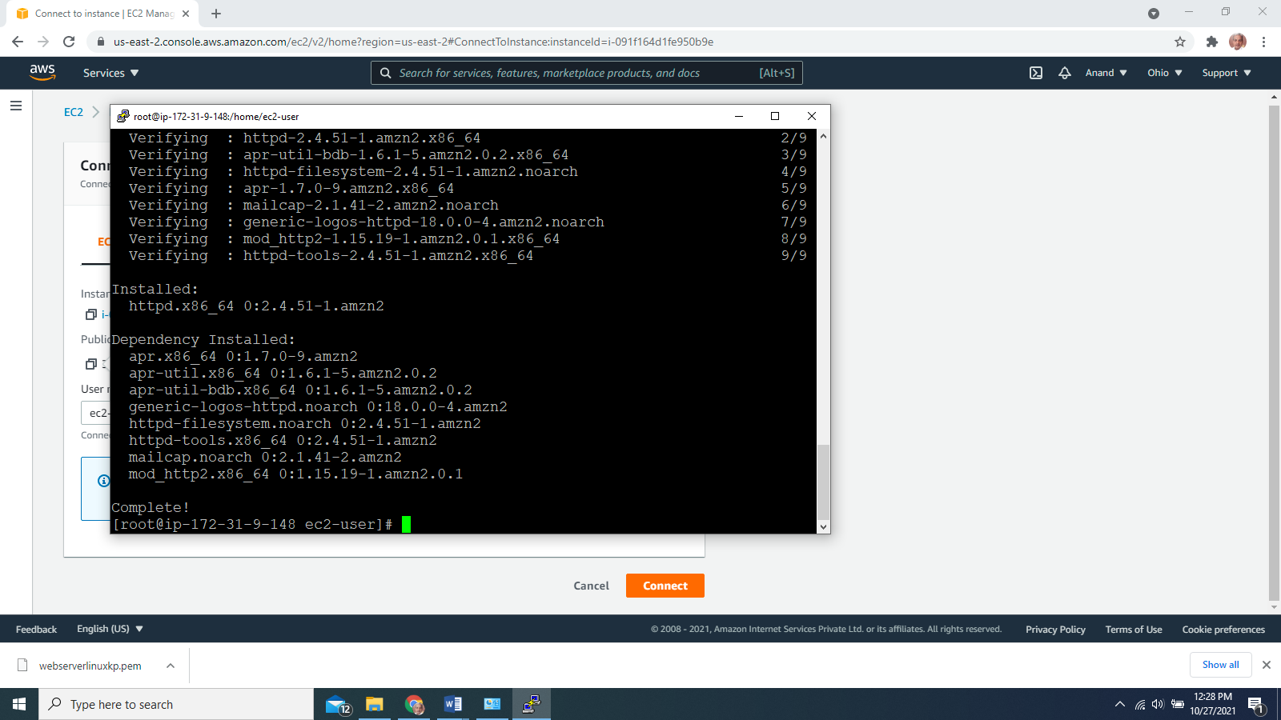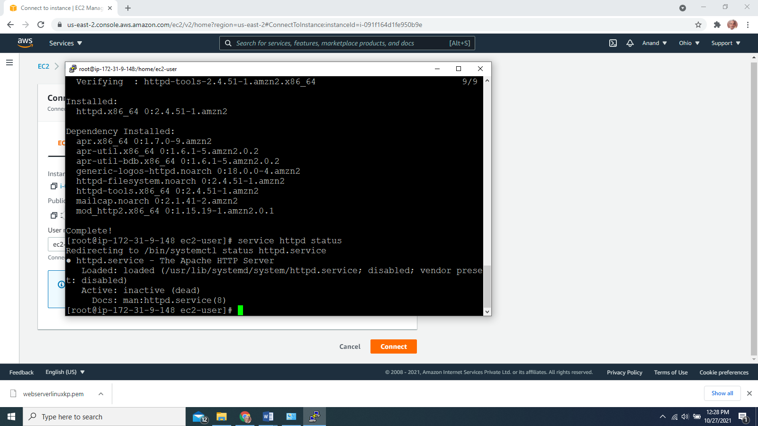

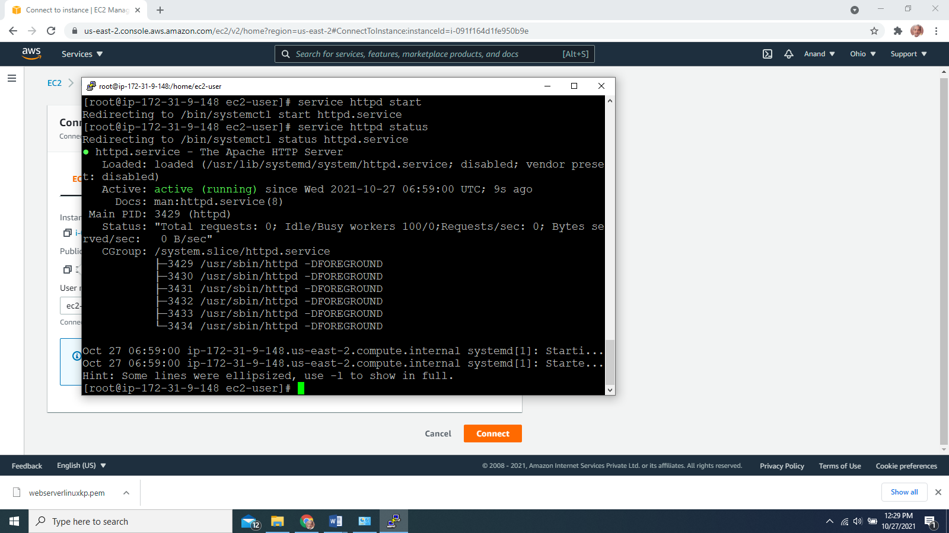

paste the public ip on any browser any machine the below page will be displayed.

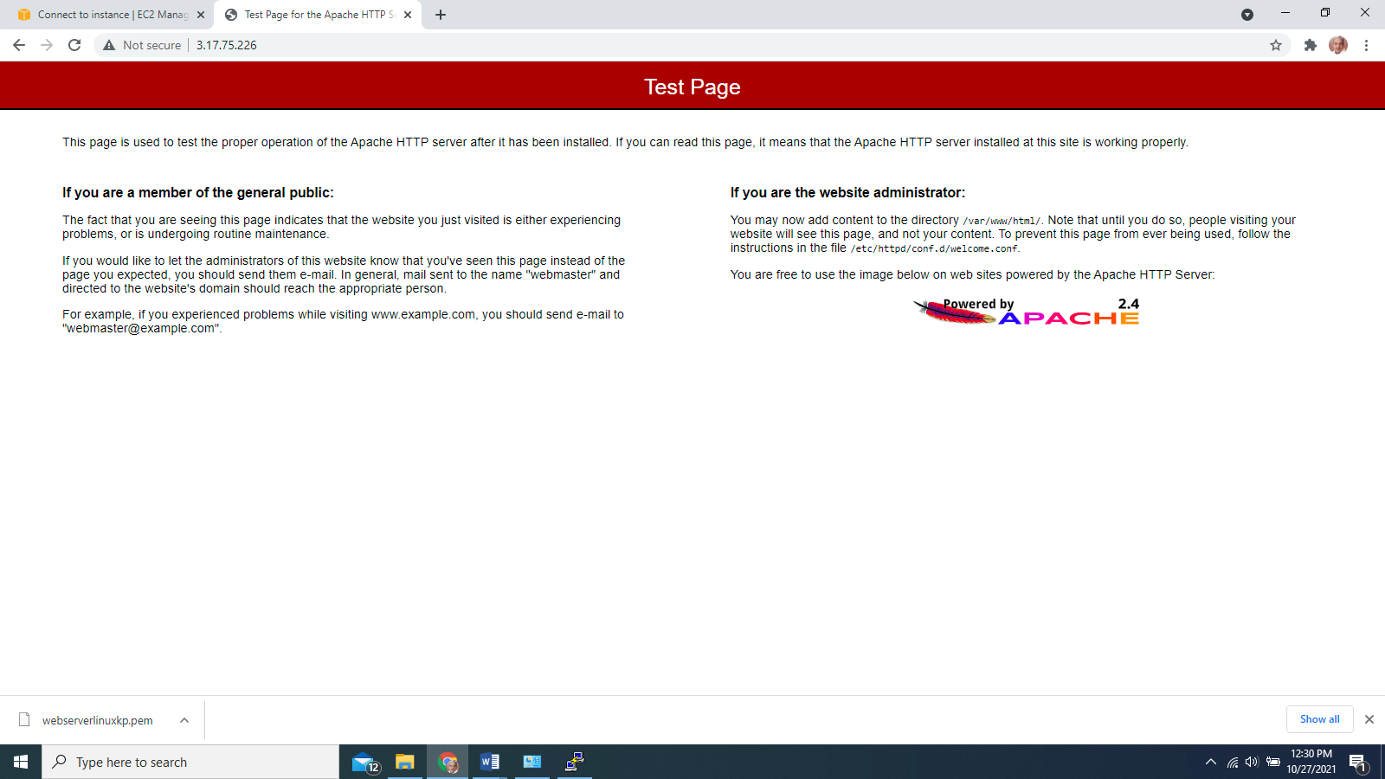

nano /var/www/html/index.html

<!DOCTYPE html>

<**html**> <**head**>

<**title**>Basic Web Page</**title**>

</**head**>

<**body**> Hello World! </**body**>

</**html**>

ctrl x to save.

paste the public ip on any browser any machine the below page will be displayed.

